Social Networking – Lab 3

Simulation Results.

Tools used, Gephi and Python.

Gephi Project and Python Source code are attached.

The python project can be used to generate the adjacency matrix and plots from (p=0.01 to 1).

The adjacency matrix can be import into gephi and visualized further.

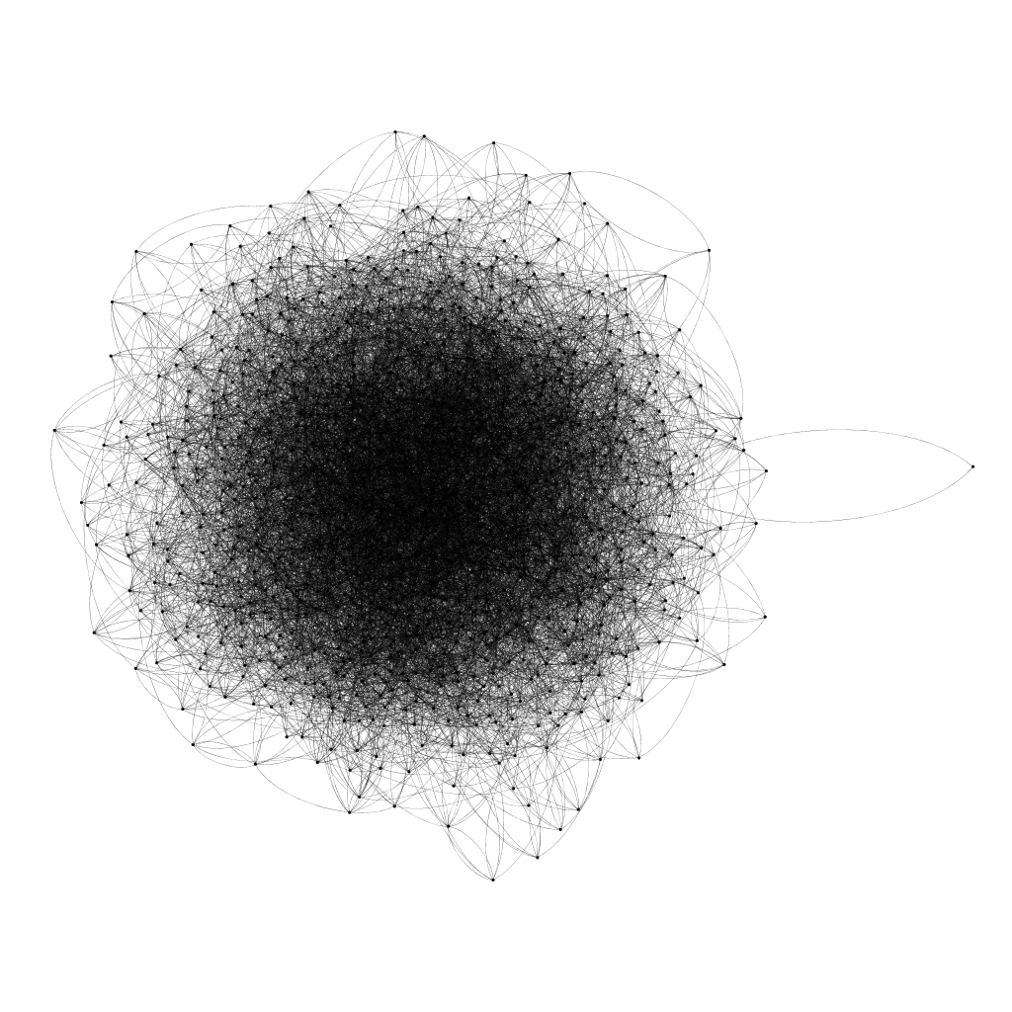

Gephi Visualization



Python NetworkX Visualization

